Battery State-of-Charge and Remaining Charge-Time Estimation from Li-ion Drive-Cycle Data
Project Report | TIH, IIT Guwahati internship project
Name: VUDA JAYA SAI GANESH | Group: S2
GitHub repository: https://github.com/SaiGanesh112006/TIH_VUDA_JAYA_SAI_GANESH/tree/main/

1. Abstract
This project estimates the state of charge (SOC) of an LG 18650HG2 Li-ion cell from voltage, current, cell temperature, power and ambient temperature, and estimates remaining charging time inside charging segments. A file-grouped train/test split prevents leakage between time-correlated rows. Both targets, SOC and remaining charging time, were studied. Candidates (mean baseline, linear regression, random forest, gradient boosting, MLP) were compared; the final model (tuned RandomForest) was chosen by grouped cross-validation with a rule fixed before the test set was opened. On the 5 held-out files it reaches MAE 27.73%, RMSE 37.71%, R² -0.417, whereas plain Linear regression reaches MAE 18.10%. Remaining charging time (the second target) was modelled with a Random Forest on charging segments; on 5 held-out charge files it reaches MAE 26,626 s (about 444 min), only marginally better than the mean baseline, because one long file dominates the error, while the four standard charge files are predicted within 2 to 39 s. The honest conclusion is that the added complexity was not justified on held-out data, and the report documents why.

2. Problem Statement and Objectives
- Estimate SOC (%) from live sensor readings: voltage, current, cell temperature, power, ambient temperature.
- Estimate remaining charging time (s) in CC-CV charge segments (second target, Section 12).
- Compare baseline and advanced models with a leakage-safe protocol.
- Identify influential features, failure conditions and limitations.
- Deliver a frozen, documented, reproducible software package.

3. Literature Review and Planning (Week 1)
Days 1-6 covered problem definition, an 8-method literature review, research framing, dataset schema design, pipeline architecture and a methodology document reviewed with the mentor. Planned pipeline: data ingestion and quality audit, leakage-safe split by file/session, feature engineering, baseline models (mean, linear), advanced models (Random Forest, XGBoost, ANN), error analysis by SOC range, and evaluation with MAE, RMSE and R². Initial success targets were SOC MAE < 5% with R² > 0.80.

4. Dataset and Data Quality (Week 2)
The dataset is the LG 18650HG2 Li-ion battery drive-cycle dataset (faculty-provided). Raw files carry a 28-row metadata header that was stripped; column names were standardised and numeric types enforced.
Check | Finding | Decision
Files / rows | 208 CSVs, 6 temperatures, ~4.95M rows | Combine; later use 25°C folder
Duplicates | 5,876 rows (0.12%) | Drop exact duplicates
Invalid voltage | 3 files (non-positive) | Flag, do not auto-delete
Current outliers | 6.75% (IQR) | Flag; high-load pulses
SOC column | Absent in raw data | Derive via coulomb counting
Table 1. Data-quality audit (Day 8-9).

5. Preprocessing and Target Definition
- Kept the 25°C folder: 36 test files (C20DisCh, HPPC, HWFET, LA92, UDDS, US06, Mixed1-8, charge files).
- Downsampled every 10th row (SAMPLE_EVERY_N = 10): 104,560 rows x 17 columns, with 0 missing values and 0 duplicates after step-transition filtering.
- SOC target: SOC = 100 x (1 + capacity_Ah / 3.0), clipped to 0-100 % (rated capacity 3.0 Ah). Mean 53.3 %, std 24.7 %.
- Power feature: power_w = voltage_v x current_a.
- Remaining charge time: time from each row to the end of its contiguous CHA (charge) segment.
- Final inputs (5): voltage_v, current_a, cell_temp_c, power_w, ambient_temp_c. No scaling or imputation.
- Excluded as leakage: capacity_ah, wh_accu, cnt, step, cycle, cycle_level, procedure, status, prog_time, step_time.
- Predictions are clipped to [0, 100].

6. Train / Test Split
Rows inside one file are strongly correlated in time, so a random row split would leak information and inflate accuracy. The split is GroupShuffleSplit by file_id, test_size = 0.2, random_state = 42 (Day 12), frozen as Dataset V1. Week 2-3 experiments used the full V1 data (104,560 rows; 76,792 train / 27,768 test). The Week 4 frozen evaluation package uses a reduced frozen set of 5,356 rows in 23 files: 18 training files (5,028 rows) and 5 held-out files (328 rows). For remaining charging time, only the 9 training / 5 held-out files containing charging segments are used, split by the same file_id groups. Hyper-parameter tuning and model selection used validation data carved from training files only; the held-out files were scored once.

7. Feature Engineering (Day 13)
Lag, difference, rolling-mean/std, C-rate, temperature-rise and interaction features were created, then pruned by correlation (>0.9) and VIF (>10), leaving voltage_roll_std5 and current_roll_std5. Engineered features performed much worse than raw ones (Linear MAE 3.47 -> 23.19; RF 3.16 -> 22.90), so they were rejected.

8. Model Experiments (Week 3)
Method | Features | MAE (%) | RMSE (%) | R²
Mean baseline | - | 23.04 | 27.51 | -0.048
Linear Regression | raw | 3.47 | 4.59 | 0.971
Linear Regression | engineered | 23.19 | 27.77 | -0.068
Random Forest | raw | 3.28 | 10.47 | 0.848
Random Forest | engineered | 22.94 | 28.92 | -0.158
Gradient Boosting (XGBoost) | raw | 3.30 | 10.08 | 0.859
Gradient Boosting (XGBoost) | engineered | 22.60 | 27.53 | -0.049
MLP (ANN) | engineered | 25.93 | 31.61 | -0.384
Table 2. All methods scored during exploration (Day 15-18, full V1 split).
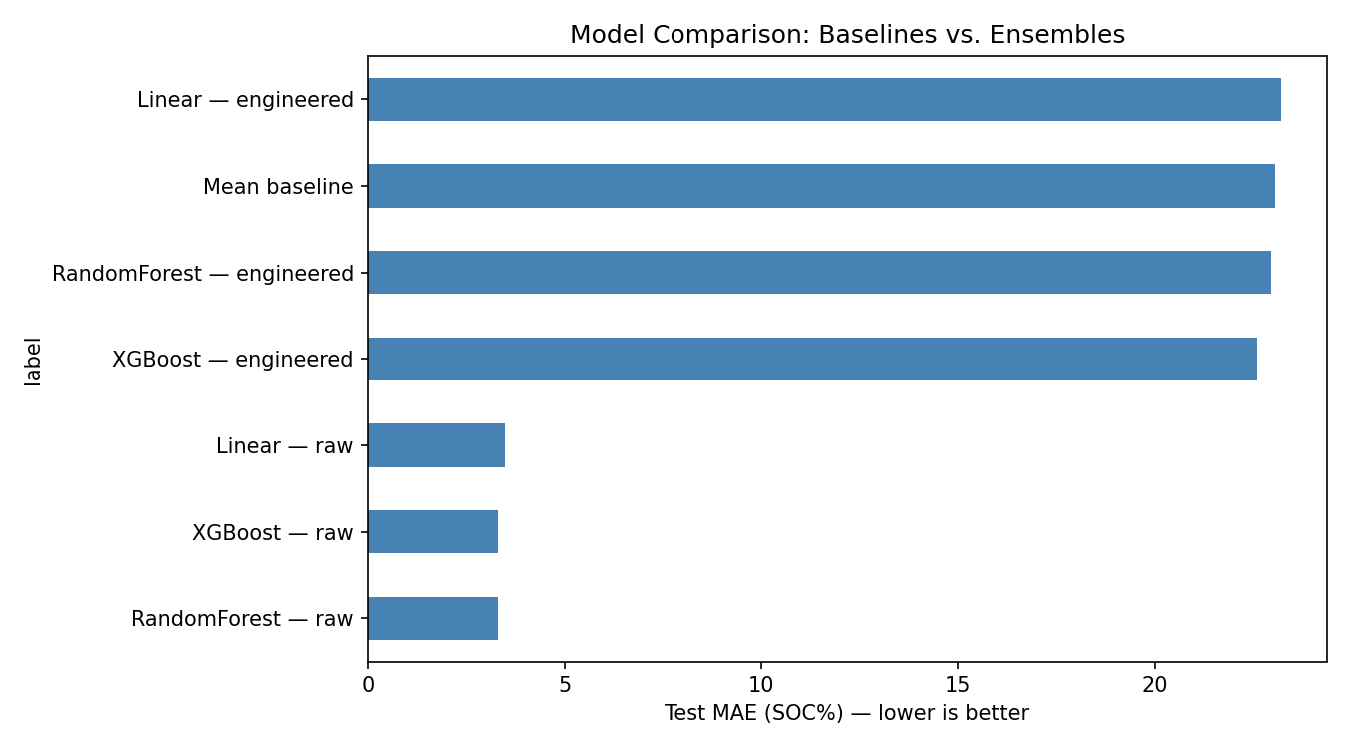
Figure 1. Model comparison by MAE (Day 16).
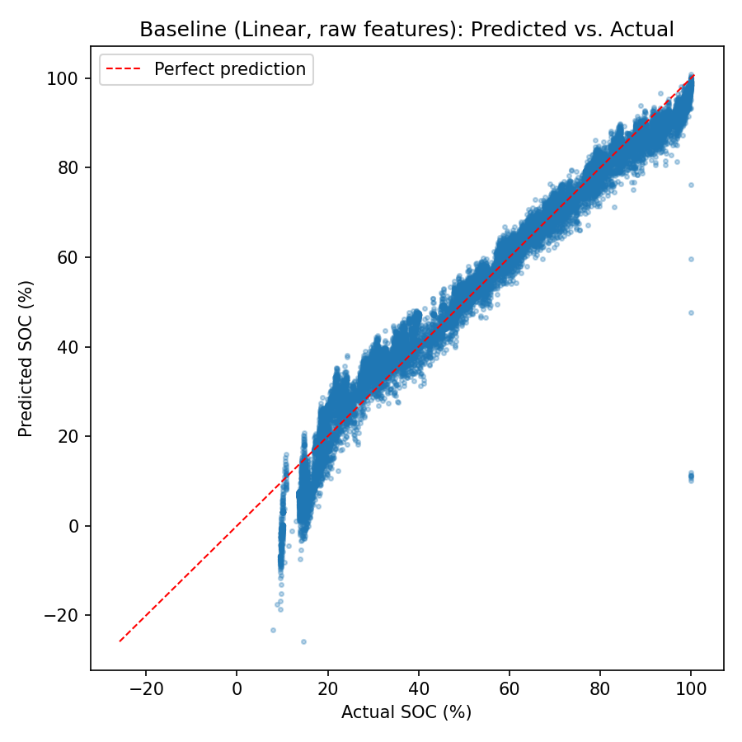
Figure 2. Predicted vs actual SOC, raw features (Day 15).
Random Forest and XGBoost on raw features scored train MAE 0.88 / 1.33 vs test MAE 3.28 / 3.30, flagged as possible overfitting. An MLP (64-32-1, 2,305 parameters) reached only MAE 25.93 and was rejected. The charge-time model (RF) reached MAE 9,002 s on the early split.
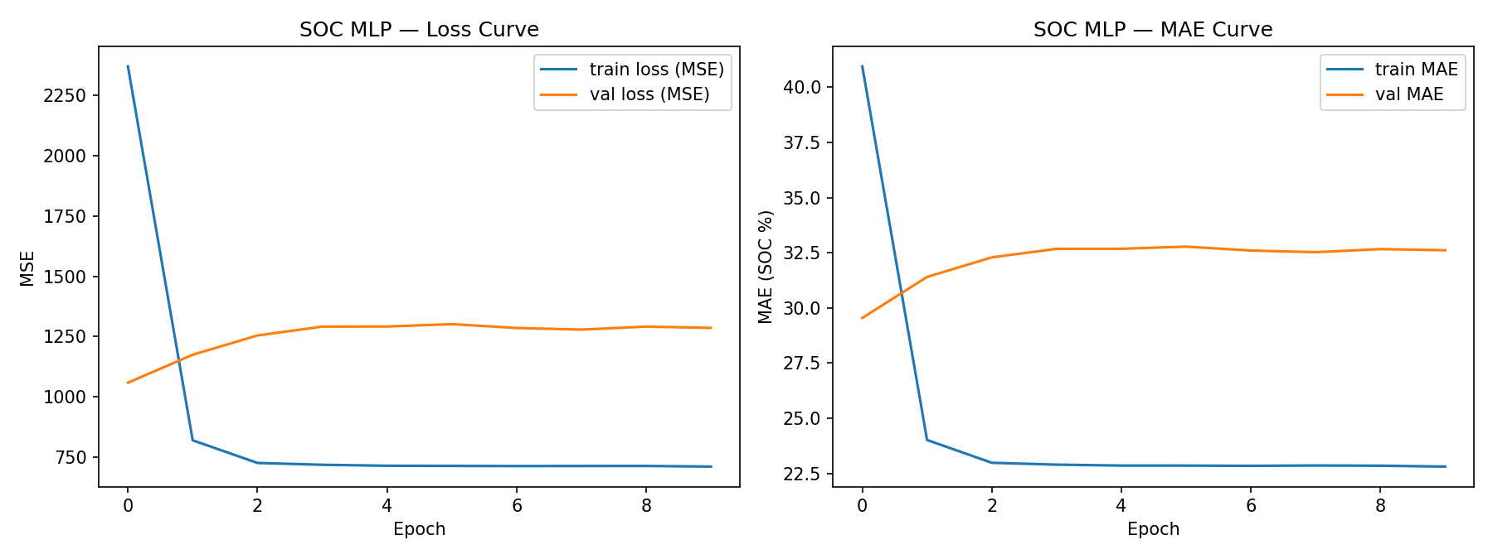
Figure 3. MLP training curves (Day 17).

9. Hyper-parameter Tuning (Day 19-21)
Grid search on a grouped validation split from training files gave RandomForest {max_depth 8, min_samples_leaf 4, n_estimators 300}, improving test MAE from 3.28 to 2.90 on the early split. On the frozen test split tuning changed RF MAE by only -0.3%.
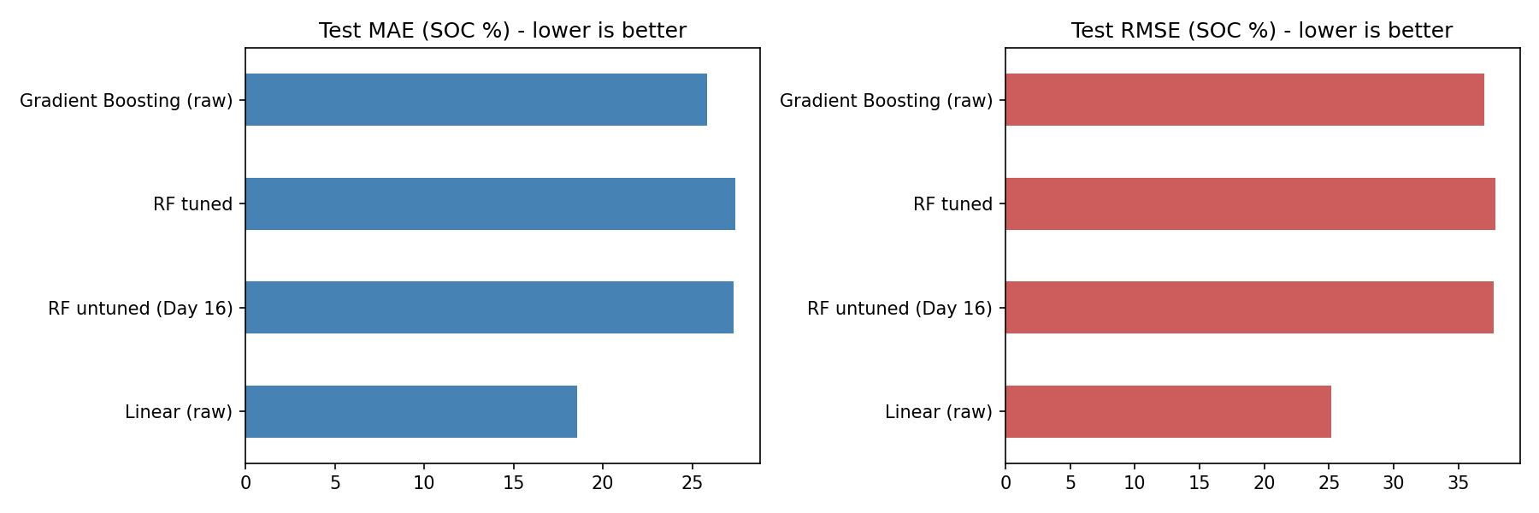
Figure 4. Baseline vs tuned models (Day 21).

10. Model Selection (Week 4, Day 22)
Selection rule (fixed before opening the test set): GroupKFold(5) on training files; any model within 10% of the best CV MAE is eligible and the simplest is chosen; robustness check requires worst fold <= 2x mean fold. RandomForest (tuned) was chosen over HistGradBoost (raw) for simplicity and stability. The robustness flag was raised (worst fold above 2x mean). For remaining charging time, a separate constrained Random Forest (100 trees, depth 10) was frozen and judged on its own, since there is only one CC-CV segment per file.
Model | Rank | CV MAE | CV RMSE | CV R² | Worst-fold MAE
Mean baseline | 0 | 39.551 | 41.769 | -8.591 | 44.118
Linear (raw) | 1 | 18.972 | 29.117 | -8.728 | 29.847
RandomForest (tuned) | 2 | 11.292 | 20.415 | -1.312 | 26.332
HistGradBoost (raw) | 3 | 10.462 | 19.363 | -1.369 | 24.125
Table 3. Grouped cross-validation on training files.
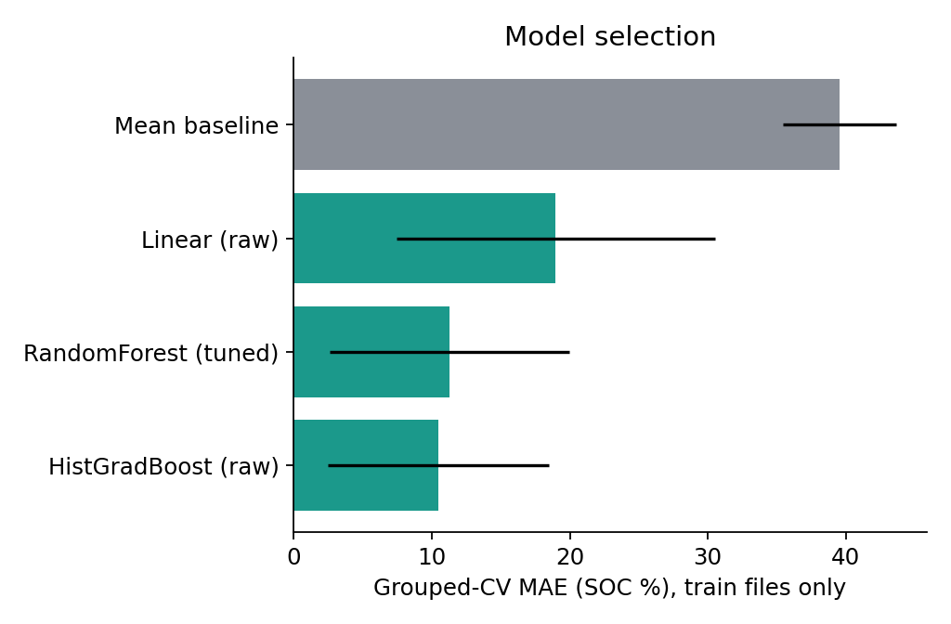
Figure 5. Cross-validated MAE of candidates.

11. Final Testing on Held-out Files
Model | MAE (%) | RMSE (%) | R²
Mean baseline | 28.93 | 32.19 | -0.033
Linear regression (raw) | 18.10 | 25.16 | 0.369
RandomForest (tuned) - frozen final | 27.73 | 37.71 | -0.417
Table 4. Final scoring on 5 held-out files / 328 rows.
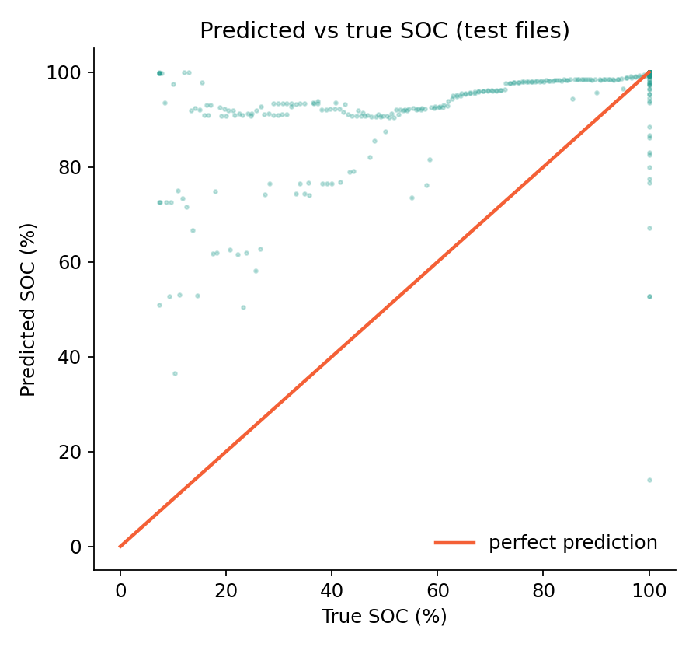
Figure 6. Held-out SOC: predicted vs true.
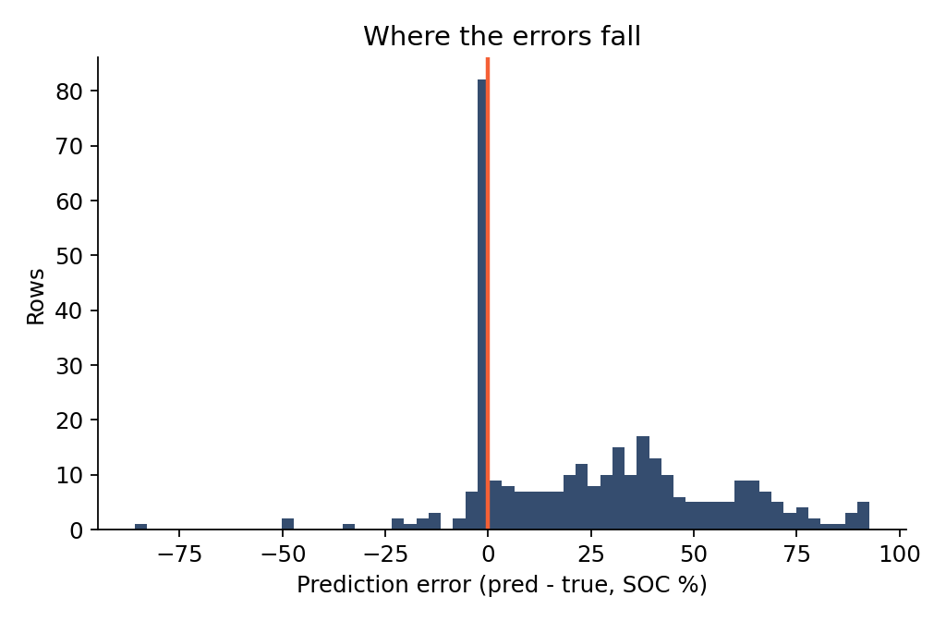
Figure 7. Error distribution.
Target | Final model | Test MAE | Test RMSE | Test R² | Confidence
SOC (%) | RandomForest (tuned) | 27.73 % | 37.71 % | -0.417 | Low; Linear (18.10 %) is better
Remaining charge time (s) | Random Forest (100 trees, depth 10) | 26,626 s (444 min) | 35,060 s | -1.285 | Low; 5 files, one dominates
Table 4b. Summary of both targets on held-out files.
The frozen RF (train MAE 1.59) generalises poorly to unseen files: R² is negative and Linear regression beats it. The Day 23 trade-off study (fit 2.15 s, single-row inference 89.6 ms vs 1.3 ms for Linear, 6.14 MB vs 0.001 MB) concludes that the complexity is not justified and recommends reverting to the simple baseline.
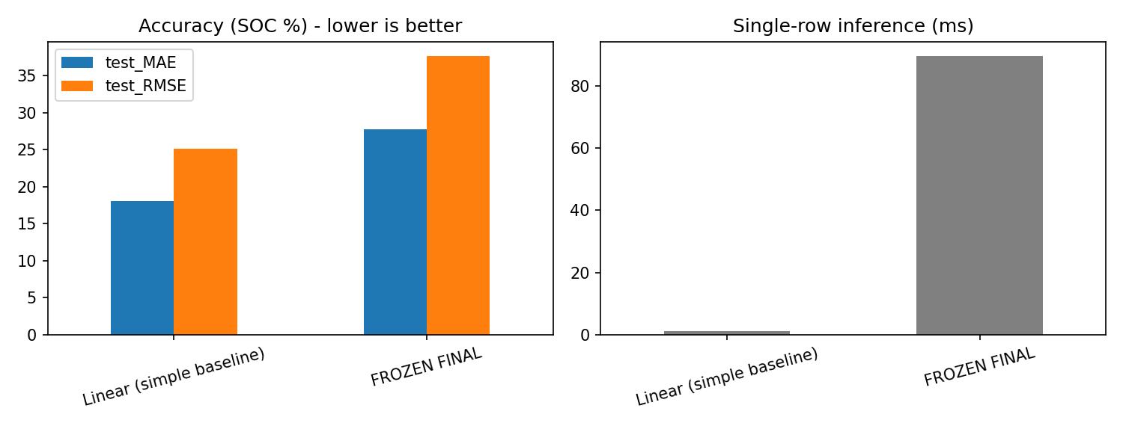
Figure 8. Accuracy vs complexity trade-off (Day 23).
Remaining charge time results are in Section 12.

12. Remaining Charging Time Estimation
Second target. Definition (Day 17): for every row inside a contiguous charging (CHA) segment of a file, remaining_charge_time_s is the time in seconds between that row and the last row of the same charging segment. Rows outside charging segments have no target. The full data holds 1,299 charging rows in 67 segments. Inputs: voltage_v, current_a, cell_temp_c, ambient_temp_c (power omitted). A neural network was explicitly not used because there are too few, repetitive CC-CV segments and it would memorise them; a Random Forest was used instead.
Progress: Day 17 first RF scored MAE 9,002 s on the early split. Day 19 tuning chose {max_depth 10, n_estimators 100}. On the frozen held-out files (153 charging rows from 5 files) the tuned RF reached MAE 26,626 s (about 444 min), only slightly better than the mean baseline (27,124 s).
Model | MAE (s) | MAE (min) | RMSE (s) | R²
Mean baseline | 27,124 | 452.1 | 35,448 | -1.336
Linear | 27,021 | 450.3 | 35,219 | -1.306
Random Forest (tuned) | 26,626 | 443.8 | 35,060 | -1.285
Table 5. Remaining charge time on held-out charging rows (Day 21).
Held-out file | Rows | MAE (s) | Max error (s)
25degC_C20DisCh | 121 | 33,663 | 69,276
25degC_Charge14 | 8 | 39.0 | 270
25degC_Charge15 | 8 | 13.9 | 42
25degC_Charge6 | 8 | 1.9 | 12
25degC_Charge8 | 8 | 6.8 | 42
Table 6. Charge-time error per held-out file.
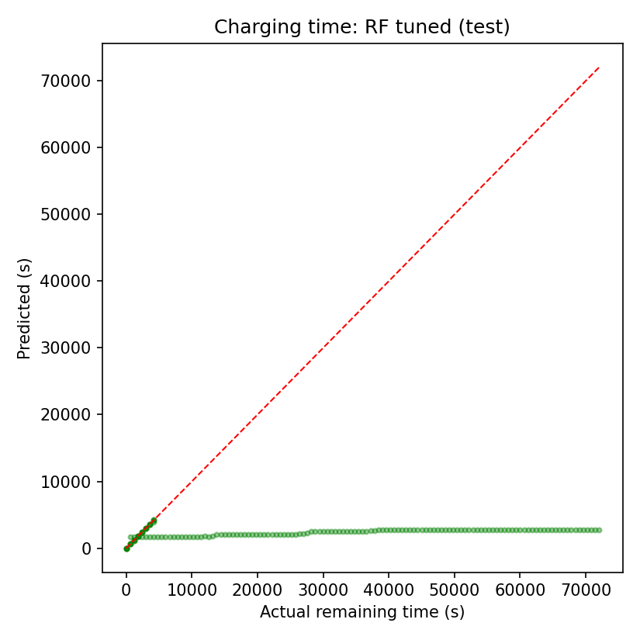
Figure 9. Remaining charge time: predicted vs actual (Day 21).
Key finding: the 4 genuine charge files are predicted very well (MAE 2 to 39 s), but the C20DisCh file contains 121 rows tagged CHA and its error of 33,663 s dominates the overall metric. The poor aggregate score is therefore driven by one long, slow-charging file with a very different time scale, plus the tiny number of segments (one CC-CV segment per file). The result is low-confidence and indicative only; more charging segments and a consistent segment definition are needed before it is a production deliverable.

13. Error and Failure Analysis (Day 25)
SOC band | 0-15 | 15-30 | 30-50 | 50-70 | 70-85 | 85-100
MAE (%) | 69.3 | 60.7 | 48.0 | 32.5 | 20.3 | 4.6
Table 7. MAE by SOC band.
Held-out file | MAE (%) | Max error | Rows
25degC_C20DisCh | 35.74 | 92.69 | 243
25degC_Charge8 | 7.90 | 85.95 | 22
25degC_Charge14 | 4.33 | 32.92 | 21
25degC_Charge15 | 4.10 | 47.32 | 21
25degC_Charge6 | 2.77 | 22.45 | 21
Table 8. Error per held-out file.
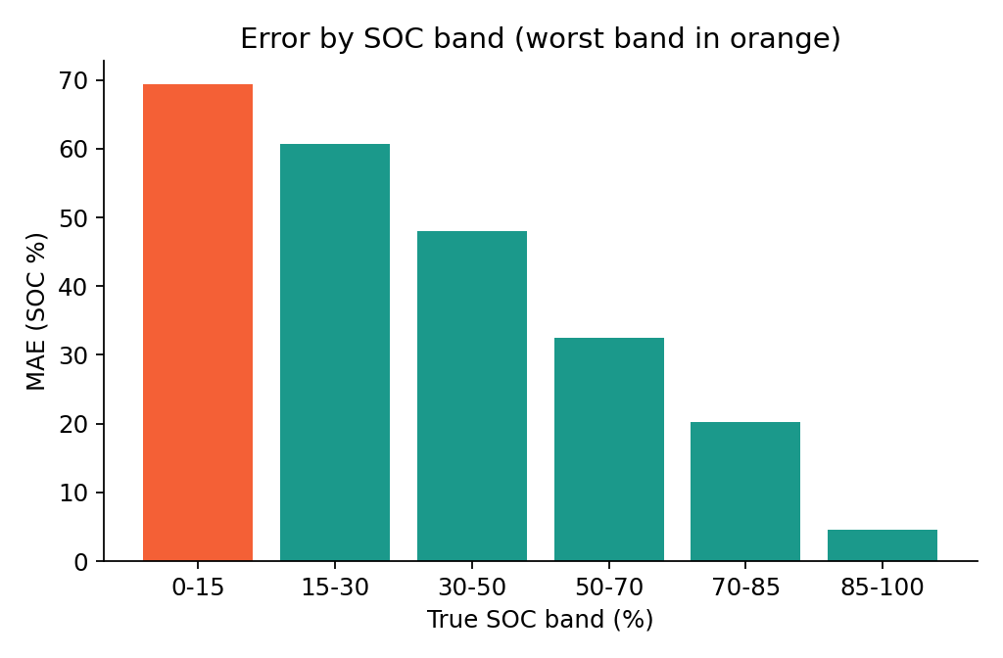
Figure 10. MAE by SOC band.
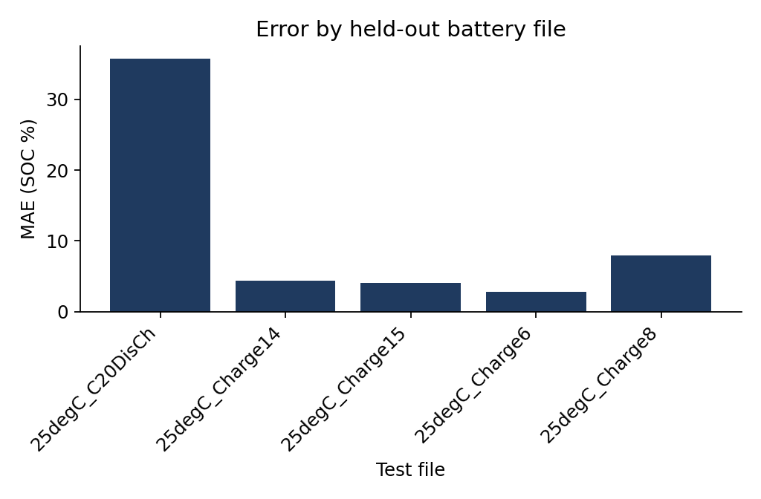
Figure 11. MAE by held-out file.
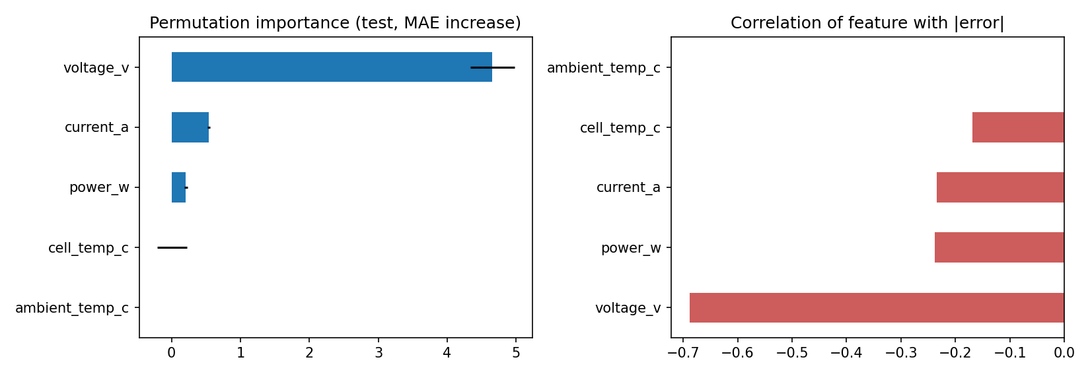
Figure 12. Permutation feature importance (voltage_v dominant).
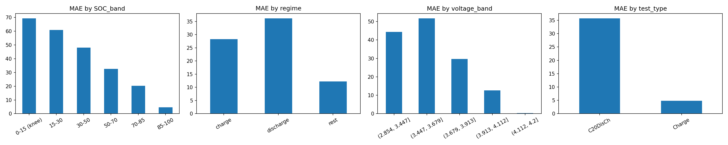
Figure 13. Errors by operating condition.

14. Limitations
- Only 5 held-out files / 328 rows: wide uncertainty.
- Largest errors at SOC 0-15% (voltage knee); one discharge file (C20DisCh) carries about 97% of squared error.
- Rows outside the training 1-99 percentile input range: MAE 37.4 vs 26.9.
- Charge time: only 5 files, one long file dominates error
- Only 25°C data; other temperatures untested.
- Static, history-free model; V, I, P are collinear.
- Engineered features unreliable; charge-time model low confidence.
- Early Week 3 results (MAE ~3) used a larger and easier split and are not comparable with the Week 4 frozen evaluation.

15. Reproducibility and Software Package
The final package (Week 4 Day 26) contains the battery_soc module (config, data, models, train, evaluate, predict), frozen models and frozen_config.json, tests (pytest), example input/output, figures and reports, and requirements.txt. Example: python scripts/predict.py --model-dir models --input data/sample_input.csv --output outputs/sample_output.csv

16. Future Work
- Sequence-aware models (windowed features, GRU/LSTM) under the same grouped protocol.
- Data at more temperatures and drive cycles; leave-one-temperature-out validation.
- Uncertainty estimates and out-of-range input detection.
- More charging segments for the charge-time model; other chemistries and ageing.

17. Conclusion
A leakage-safe, reproducible pipeline was built for both SOC and remaining charging time and rigorously evaluated. The key learning is methodological: file-grouped evaluation exposed that early optimistic scores (MAE ~3%) did not hold on unseen files (MAE 27.7% for RF, 18.1% for Linear). Simple linear regression on raw features is the better deployable SOC choice today; remaining charging time is accurate on standard charge files (error of seconds) but unreliable overall until more charging segments are collected, and the documented failure conditions guide future work.

18. Repository
https://github.com/SaiGanesh112006/TIH_VUDA_JAYA_SAI_GANESH/tree/main/

